No Show / Late Cancellation policy

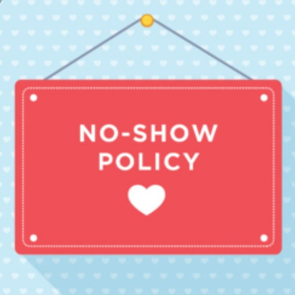

Dear All,

I’ like to remind you why we have created a no-show policy.

As you already know, each member of the PMI Belgium Chapter can attend for free the Chapter Events.

Considering:
(a) the financial impact of providing our members quality catering, locations and speakers as well as
(b) the organizational & practical limitations of our events (like the number of seats in a meeting room), the number of participants for each event is strictly limited.

Online registration for any event is mandatory and is done on a first come, first serve basis. We are confident that you understand it is very unfair to refuse registrations on the one hand and observe that registered persons simply do not show up at events on the other hand.

Please realise that the sunk cost is approx 40 EUR (Excl. VAT) for each no-show/late-cancellation. Keep your PMI code of ethics in mind and notify us formally and in due time in case of unexpected change of your priorities or plans.

Our online event-registration process requires you to enter all fields manually. Your registration will be confirmed by email.

In case the number of registrations exceeds the number of available seats, you can send an email to events@pmi-belgium.be. As soon as we have a cancellation, you’ll be informed that you can register.
The registration cancellation is equally simple: send an email directly to events@pmi-belgium.be

If you don’t cancel on time, you’ll receive an email asking you to pay 40€. After 3 no shows, you’ll be blacklisted and you’ll have to pay for the event.

Thanks for your understanding.

Looking forward to seeing you all at future events.

Kind regards,

Christine Dassy
Director of PM Fair & Events 2018-2019

